Mini Mental State Examination (MMSE)

Maximum Score
Orientation
5 ( 0 ) What is the (year) (season) (date) (day) (month)?
5 ( 0 ) Where are we (state) (country) (town) (hospital) (floor)?
Registration
3 ( 3 ) Name 3 objects: 1 second to say each. Then ask the patient
all 3 after you have said them. Give 1 point for each correct answer.
Then repeat them until he/she learns all 3. Count trials and record.
Trials ___________
Attention and Calculation
5 ( 0 ) Serial 7’s. 1 point for each correct answer. Stop after 5 answers.
Alternatively spell “world” backward.
Recall
3 ( 2 ) Ask for the 3 objects repeated above. Give 1 point for each correct
Answer
Language
2 ( 2 ) Name a pencil and watch.
3 ( 0 ) Repeat the following “No ifs, ands, or buts”
3 ( 0 ) Follow a 3-stage command: “Take a paper in your hand, fold it in half, and put it on the floor”
1 ( 0 ) Read and obey the following: CLOSE YOUR EYES
1 ( 0 ) Write a sentence.
1 ( 0 ) Copy the design shown.

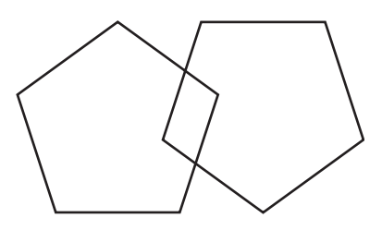 Total Score___5____
ASSESS level of consciousness along a continuum ____________
Alert Drowsy Stupor Coma

("MINI-MENTAL STATE." A PRACTICAL METHOD FOR GRADING THE COGNITIVE STATE OF PATIENTS FOR THE CLINICIAN. Journal of Psychiatric Research, 12(3): 189-198, 1975.)

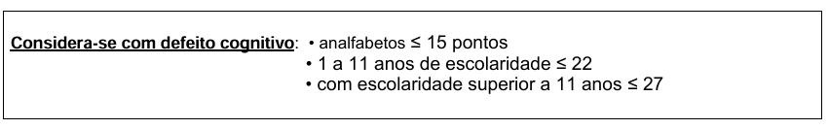

A utente obteve 5 pontos de 30 possíveis.
Através deste resultado, concluo que a Sra M.M.V. apresenta dificuldades significativas em realizar tarefas básicas que requerem memória, atenção ou orientação.
Por outro lado, conclui-se que tem dificuldade para realizar atividades da vida diária (AVD´s), como comer, vestir-se, tomar banho ou lembrar compromissos simples.

